* **Optional Task: Write an RMI program to implement the Map/Reduce concept of Hadoop on the server program. In other words the client program asks user to provide multiple sentences and send to server, server sends back the word counts.**

**Interface:**

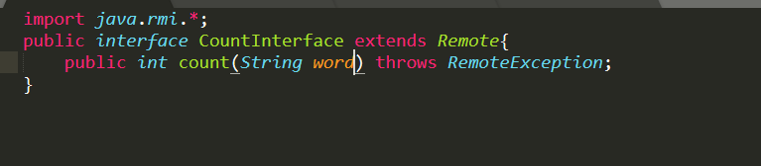

**Server:**

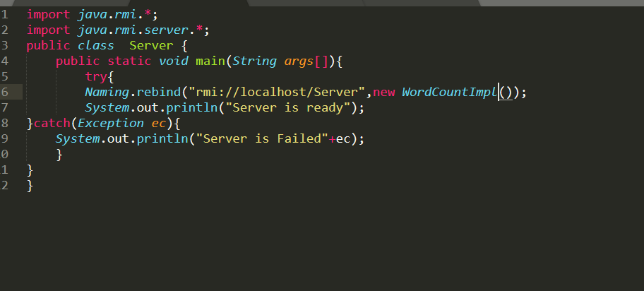

**Client:**

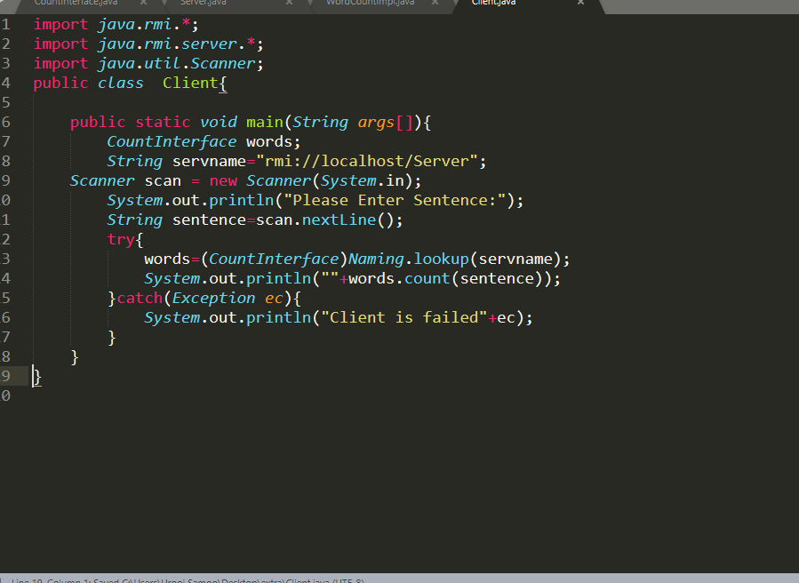

**Remote Class:**

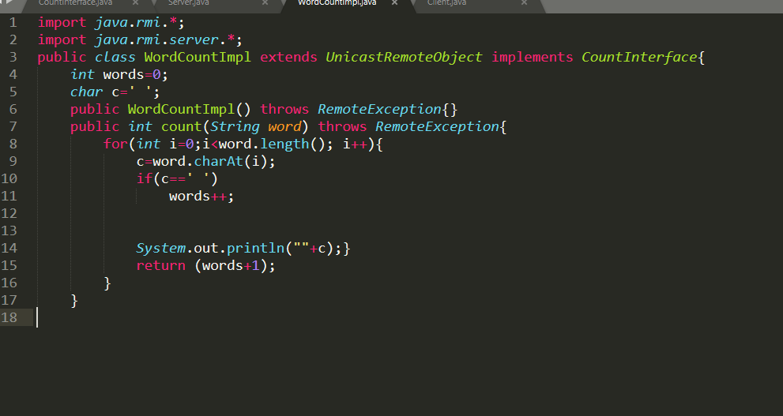

**Output:**

